Documentation

Homepage

Logo

The homepage Is the main mage of my design and is here to attract people to the website. The header is at the top of the page and is started with the logo of Riget Zoo Adventures. I tried to encapsulate the company as much as possible in this logo but also keep a minimalist design to not overcomplicate the header.

I also implemented a feature that allows the user to return to the homepage whenever clicking on this image which can be helpful as it is a quick and easy way to navigate the website. To the right of the logo is the nav bar which consists of the Homepage, Popular animals, About, Sign – up, Booking and the Contact us page. These all work and when clicked redirect you to the corresponding page.

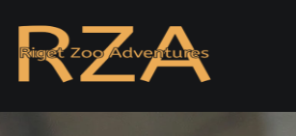

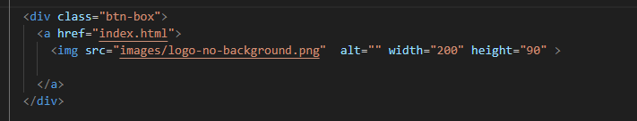

Nav bar

To the right of the logo is the nav bar which consists of the Homepage, Popular animals, About, Sign – up, Booking and the Contact us page. These all work and when clicked redirect you to the corresponding page. I also implemented a feature that makes it so the current page is underlined in the navbar which can help the user know where they are on the website.



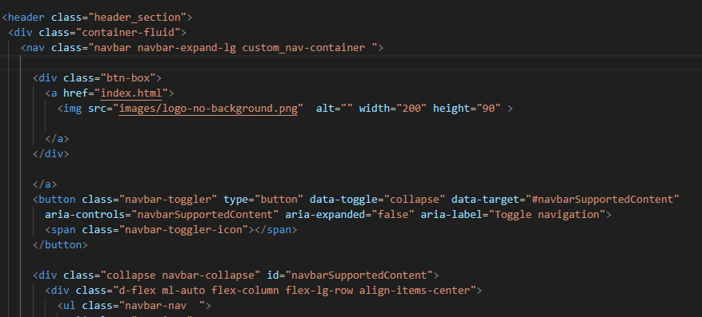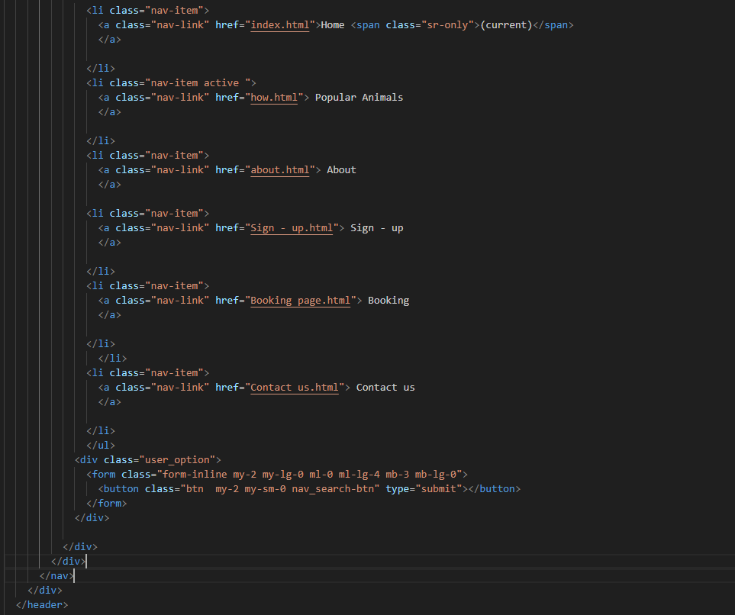

Search icon

To the right of this is a search button. Though I didn’t have time to make this function correctly in principle it would be great to help the user navigate the website quickly.



CODE SS

Background image

The header for most of the pages are the same to save myself repeating the design I will just refer to it as having the header. Under this there is an image of a snow leopard this is meant to display one of the best animals that is in the zoo as you will want to impress the viewers as many of them will decide if they want to proceed after seeing this homepage. This covers the entirety of this page’s section and is this way to make the image feel integrated and part of the website page.

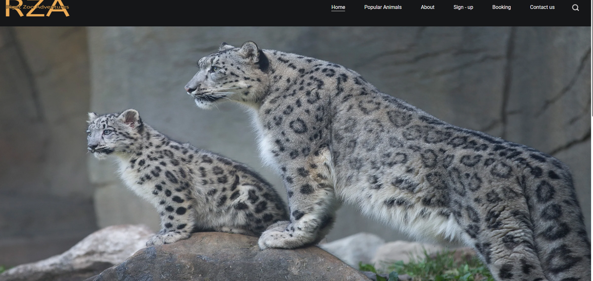

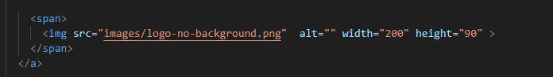

I also implemented a cookie system that the user must press accept on in for it to disappear.

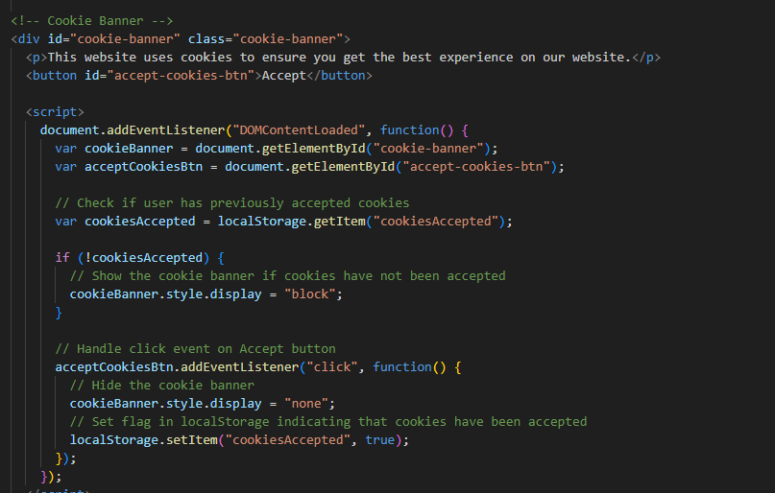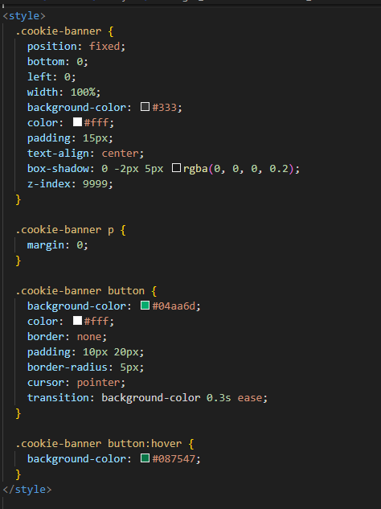

Reviews

Next in the page is a section dedicated to a pair of reviews that can be used to verify the validity of the company as when someone sees this, they will begin to trust the website as they have seen others have had a good experience. it starts with a title labelled reviews which was underlined. Then I have tried to make the images fit into the box but I didn’t manage to find out how to do it, so I moved on to the next part as I felt it wasn’t a pressing issue and under this image of them, I came up with their names. To the right of this there is a paragraph of describing how they found their experience and whether they want recommend it.

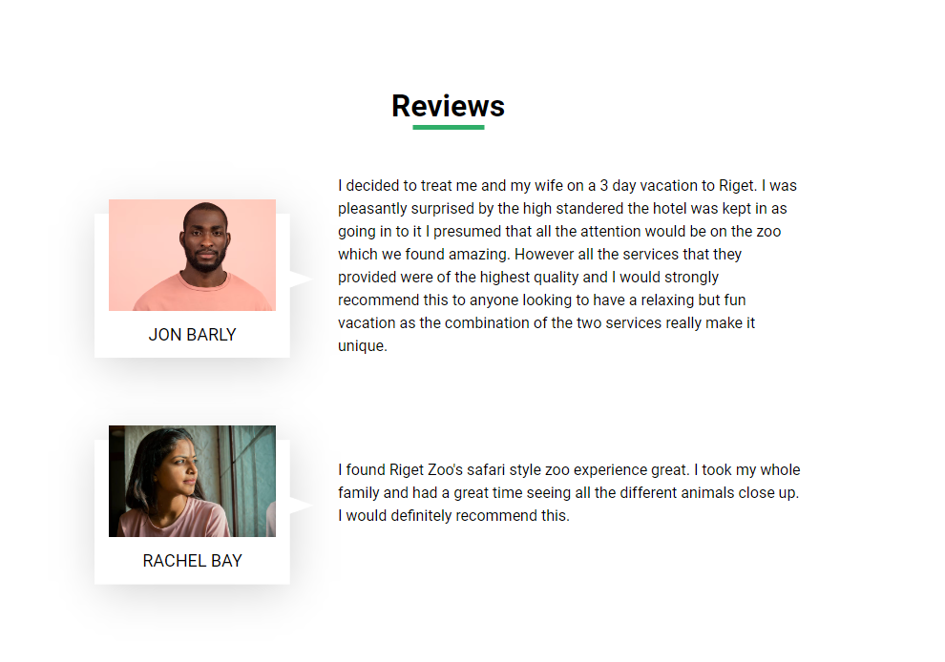

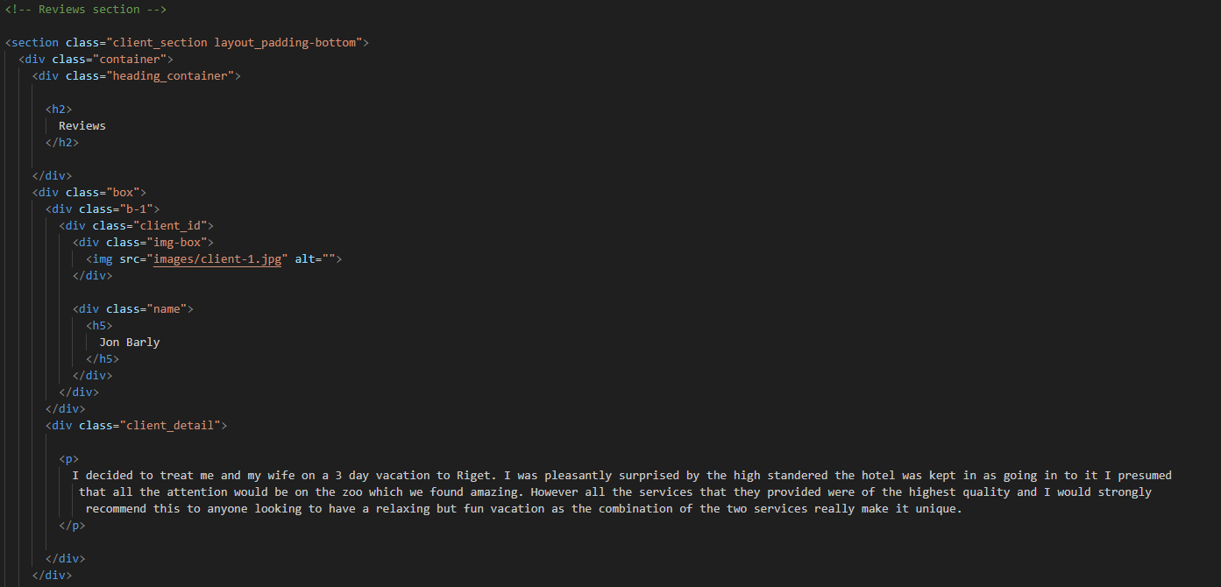

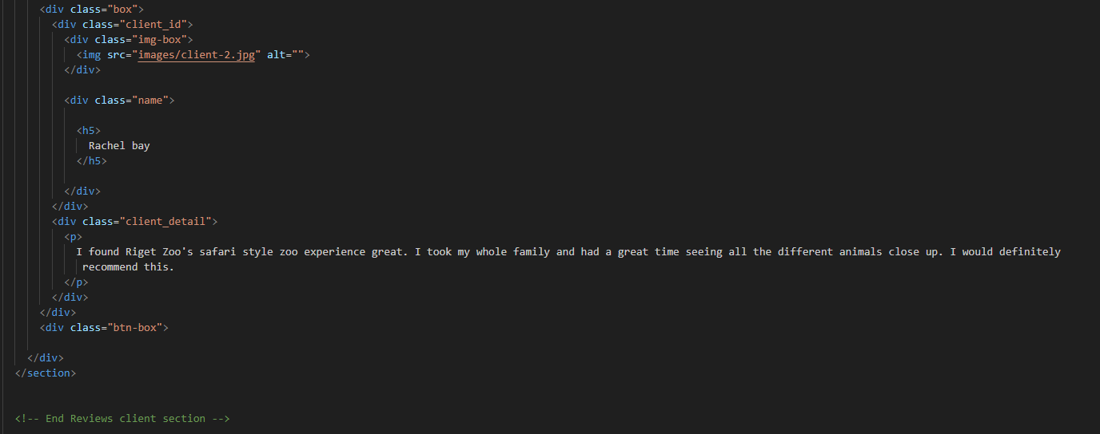

Contact

Under this is the footer. The beginning of the footer holds some contact information about the Zoo that being the location, Email address and Phone number all of this information has an icon to its left example the location has an icon of a point of interest and the Phone number has an icon of a phone.

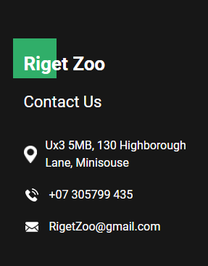

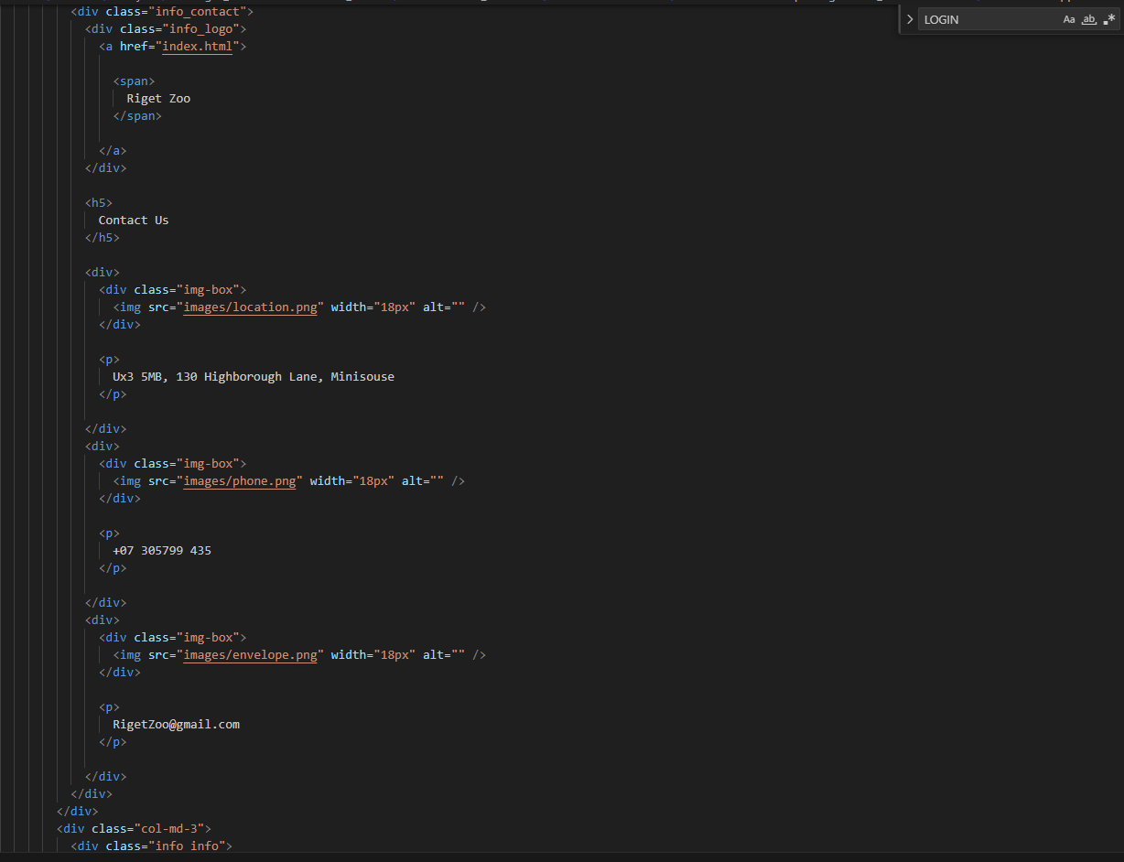

Useful links

Next in the footer is a list of useful links, these links follow the same structure of the nav bar as there is a list of the page names which are in the form of hyperlinks so as soon as they are pressed they redirect you to the page that was highlighted.

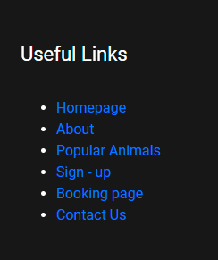

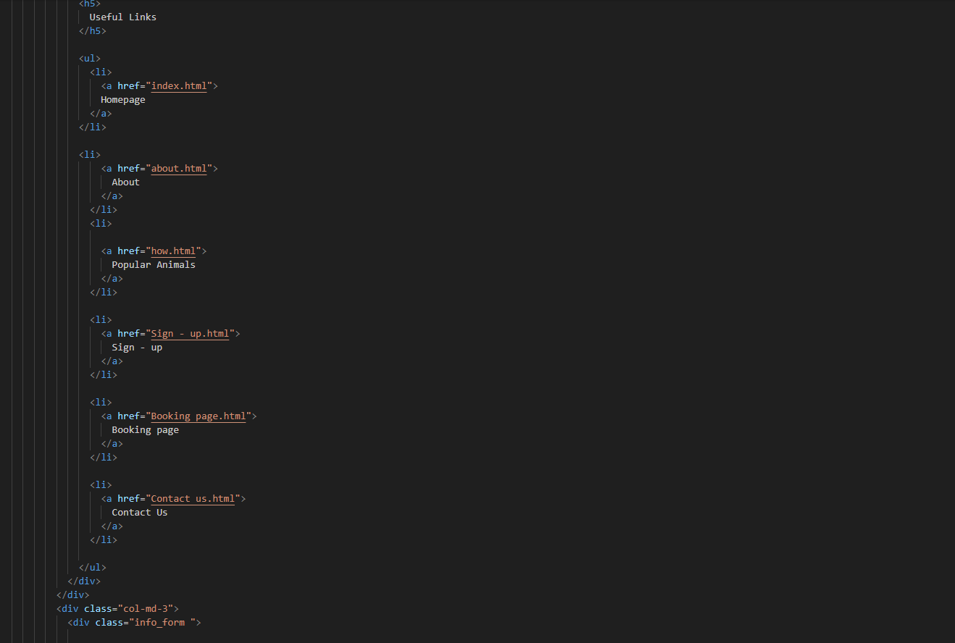Newsletter

The final element of the footer is the Newsletter, For this feature you need to enter your email address into the text box and then if you have entered a valid email address then when you click subscribe then it should take you to a page thanking you for subscribing and letting you know that you will receive an email every Friday. Just like the header most of the pages have the same footer and to save myself repeating the design I will just refer to it as having the footer

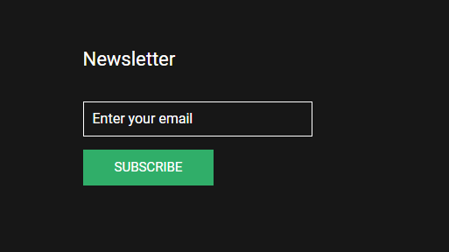

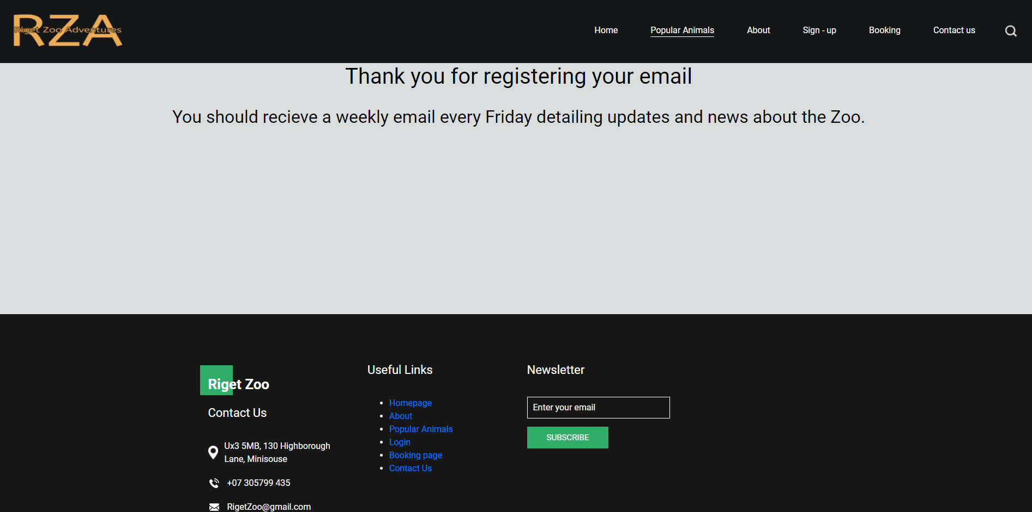

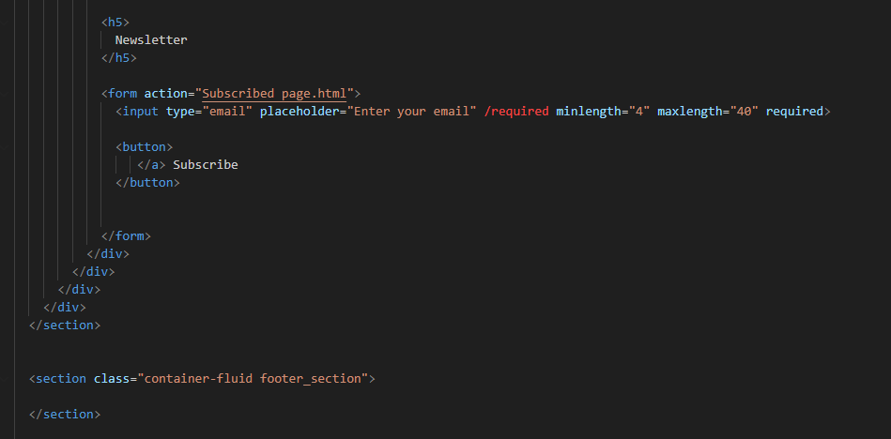

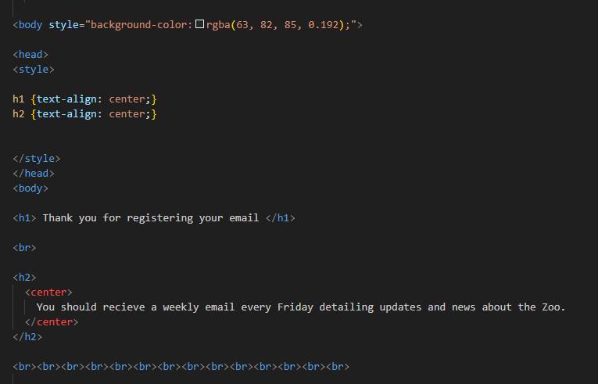

Popular animals

This has the same header and footer as the homepage but where it differs is the content as the content of this page is 4 boxes which are filled with 4 different images and under the image it displays the name of the animals (this being their species name and a personalised name). This is then followed by a paragraph beneath the name describing the animal and giving some insight on how the animals actually are. This can be used by people as educational materials as young people would familiarise themselves with the animals name some of their characteristics. This would help educate the younger generation and let them learn and appreciate their fellow peers on this earth. One thing with this page however is that you have to hover over the animal in order to see the description clearly as the writing will turn black when hovering over it. I didn’t know how to change this so I skipped it as I felt though it may be a pain point it doesn’t drastically affect the usability.

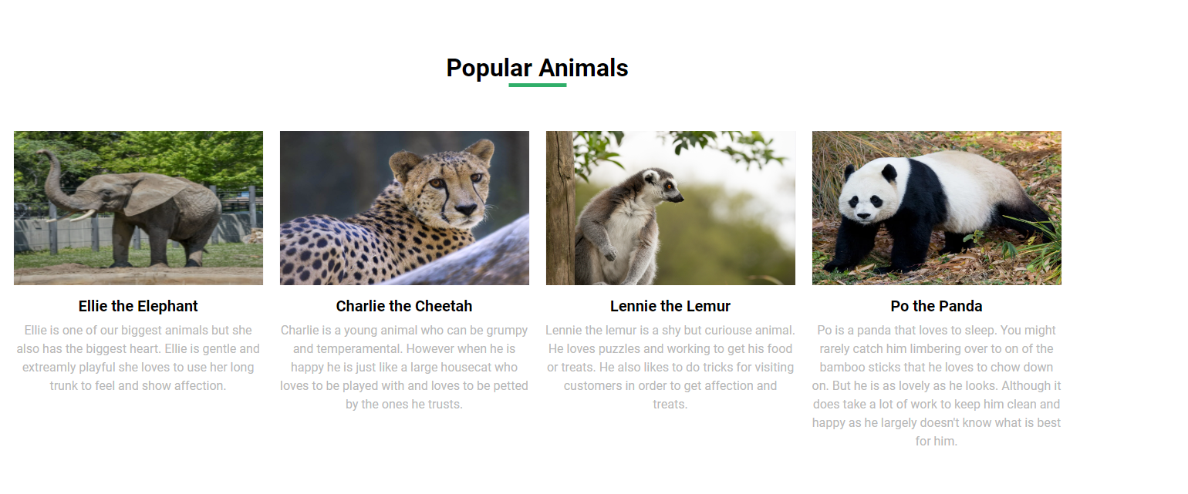

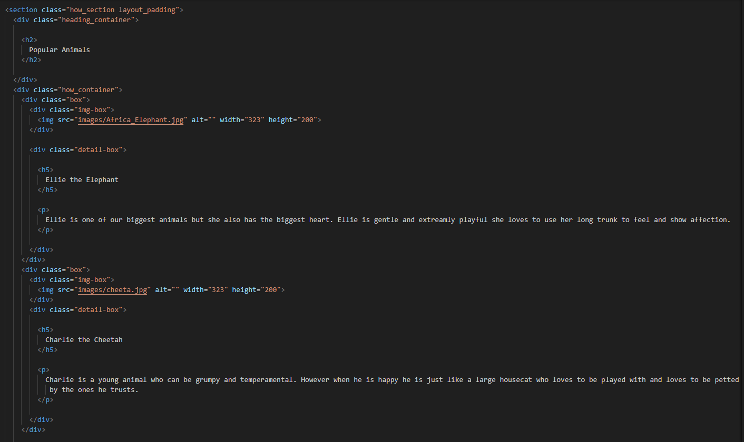

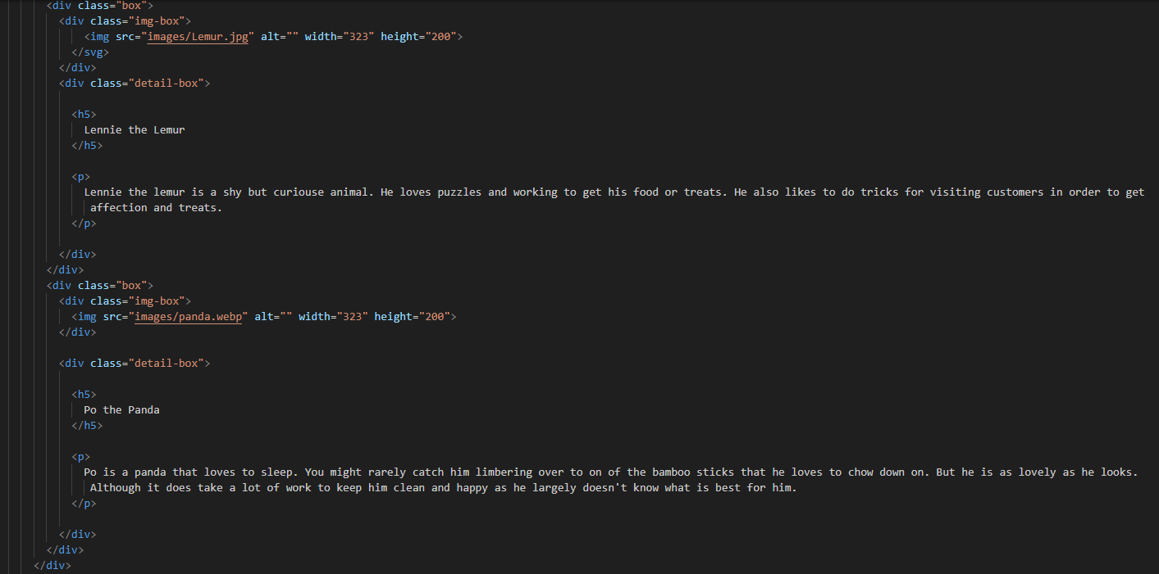

Many more

beneath this there is a button that reads there are many, MANY more. This button once clicked will take you to a page with more animals. This page should include many animals all with their own unique name and a small descriptions similar to the ones on the popular animals page. However, I didn’t have enough time to make it as detailed as I wanted to so I just made the page that was linked to the button display to the user that we are introducing more animals and this page will see more animals added. This page will also have both the footer and the header.

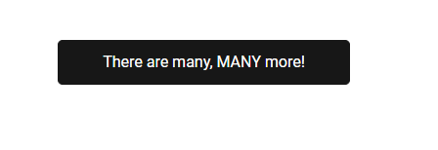

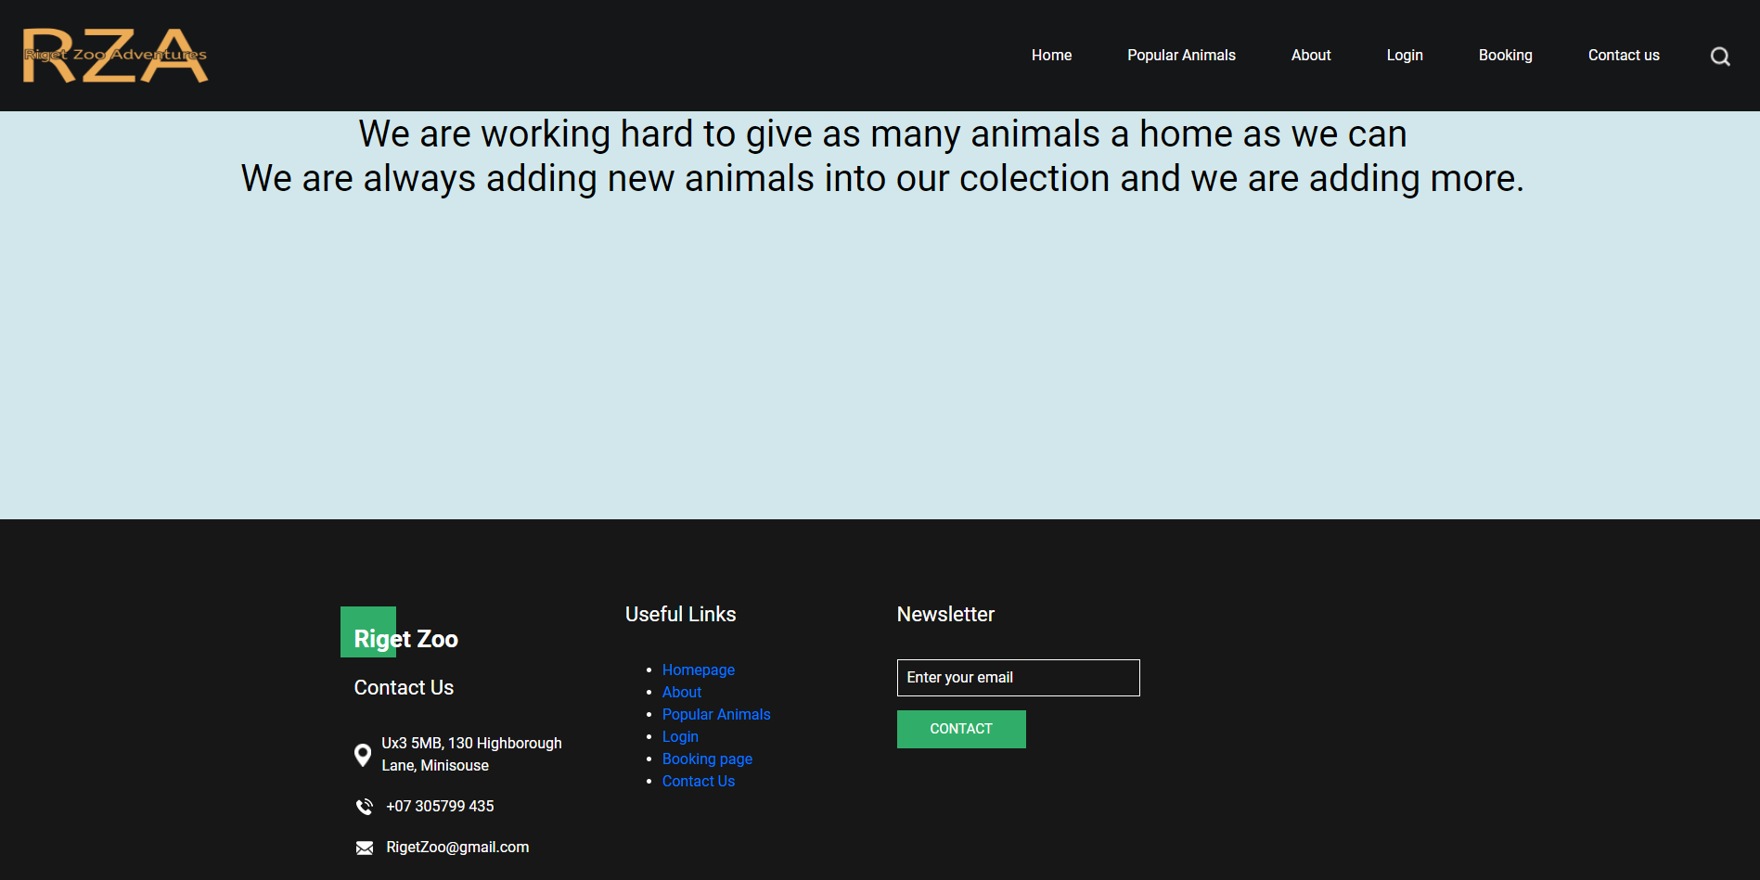

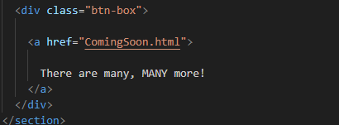

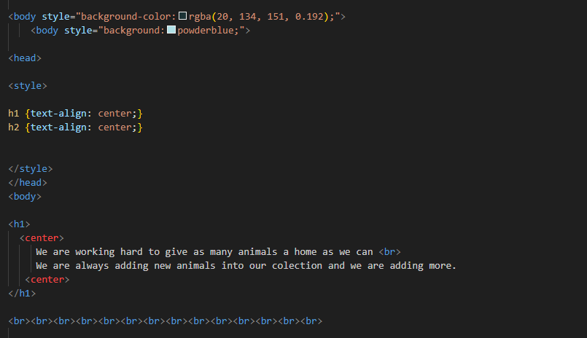

About us

The header and footer are the same but the content is where there is a change and as there is a header at the top called About and then beneath that there is an image of 2 lions.

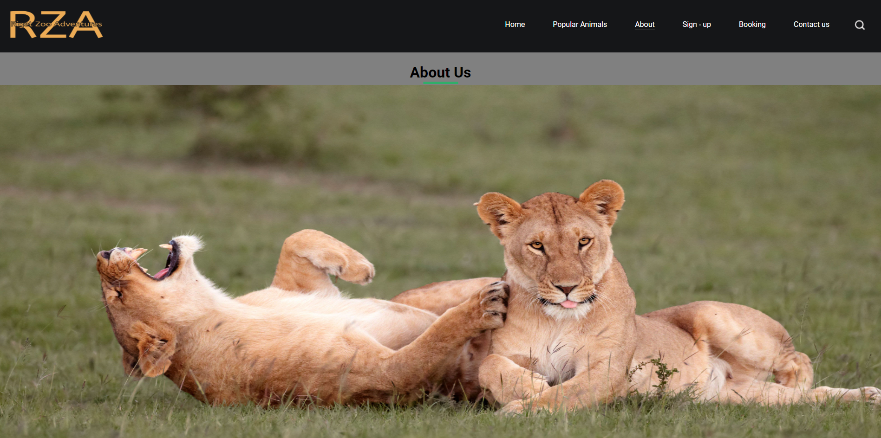

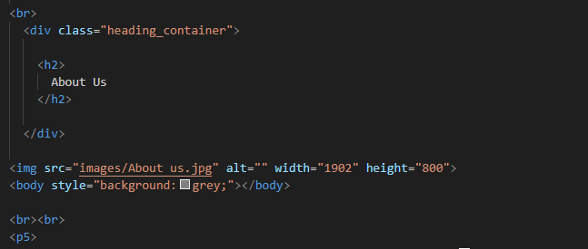

then beneath this there is an actual paragraph describing the work that is done at the zoo and why you should pay it a visit

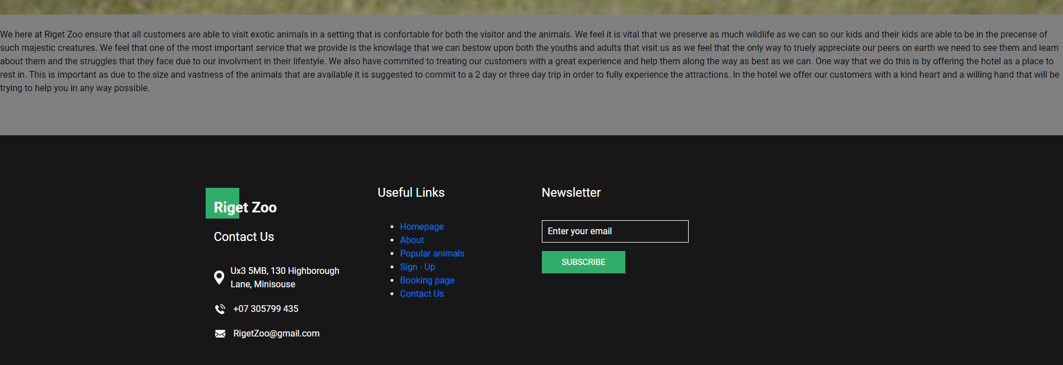

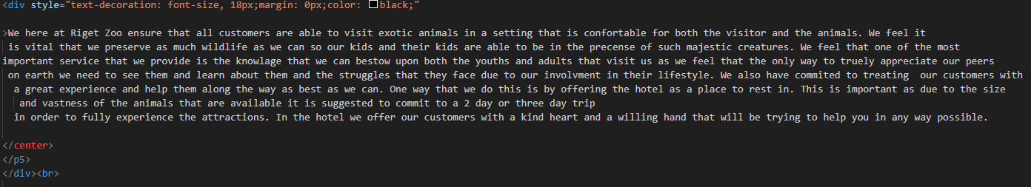

sign - up page

The login page doesn’t have the same header and footer as all of the other pages. It instead has a button at the top that when clicked redirects you to the home page.

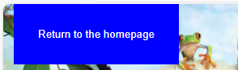

for the sign – up page the main piece of content that needs to be filled out is the box in the centre of the page. The box begins with the header Sign – Up and then moving down the box there are three fields that need to be filled in order to sign in. Those being the Email address, username and password. After you have fully entered all of the data that is required and meet the requirements then you can click the sign up button underneath the fields and this should take them to the login page and the user should enter the same details into this form to gain access to the user dashboard. The user can skip straight to the login page if the user already has an account.

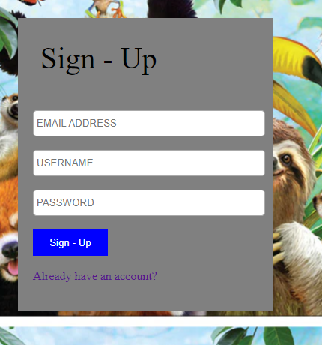

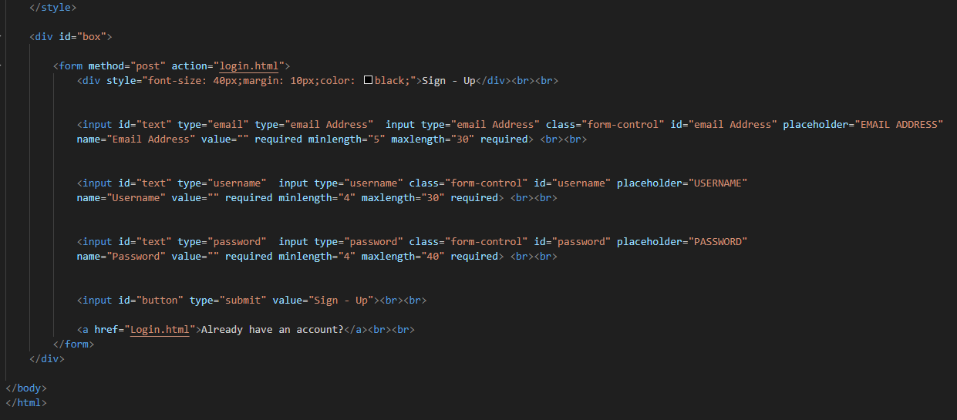

Sign – up V2

I went back to the sign – up page and decided I wanted to change the CSS for this page. I also added a terms and conditions link that takes you to a page in which it highlights the terms and conditions of this website.

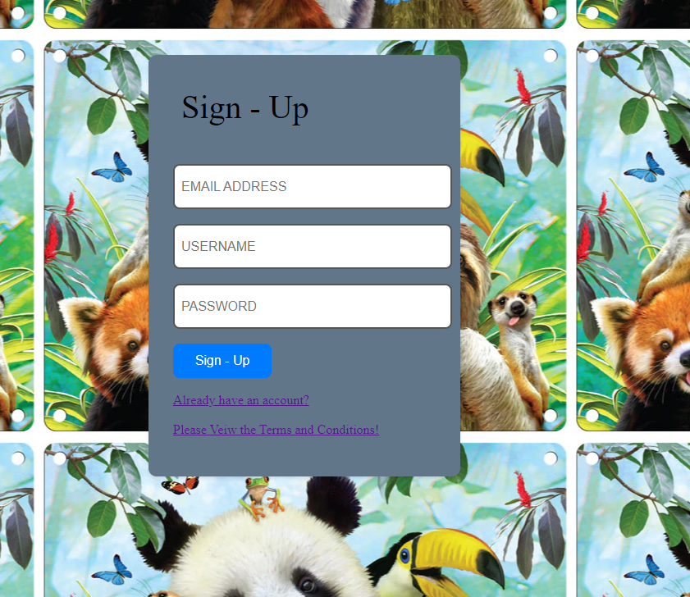

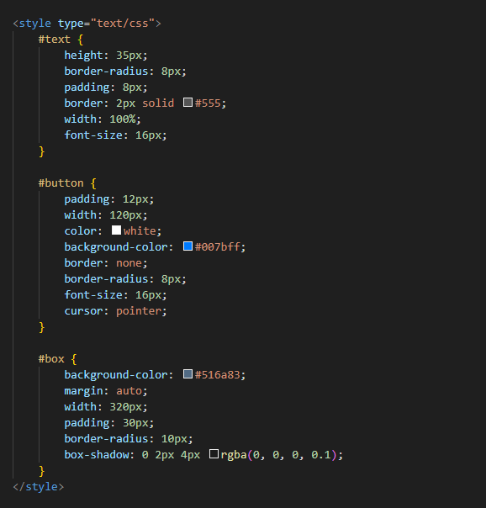



TOS page

This page the has the same header and footer as the other pages but there is much more content and the content of this page is though I have tried to follow PEP 8 guidelines quite messy and hard to view this is what I came out with.

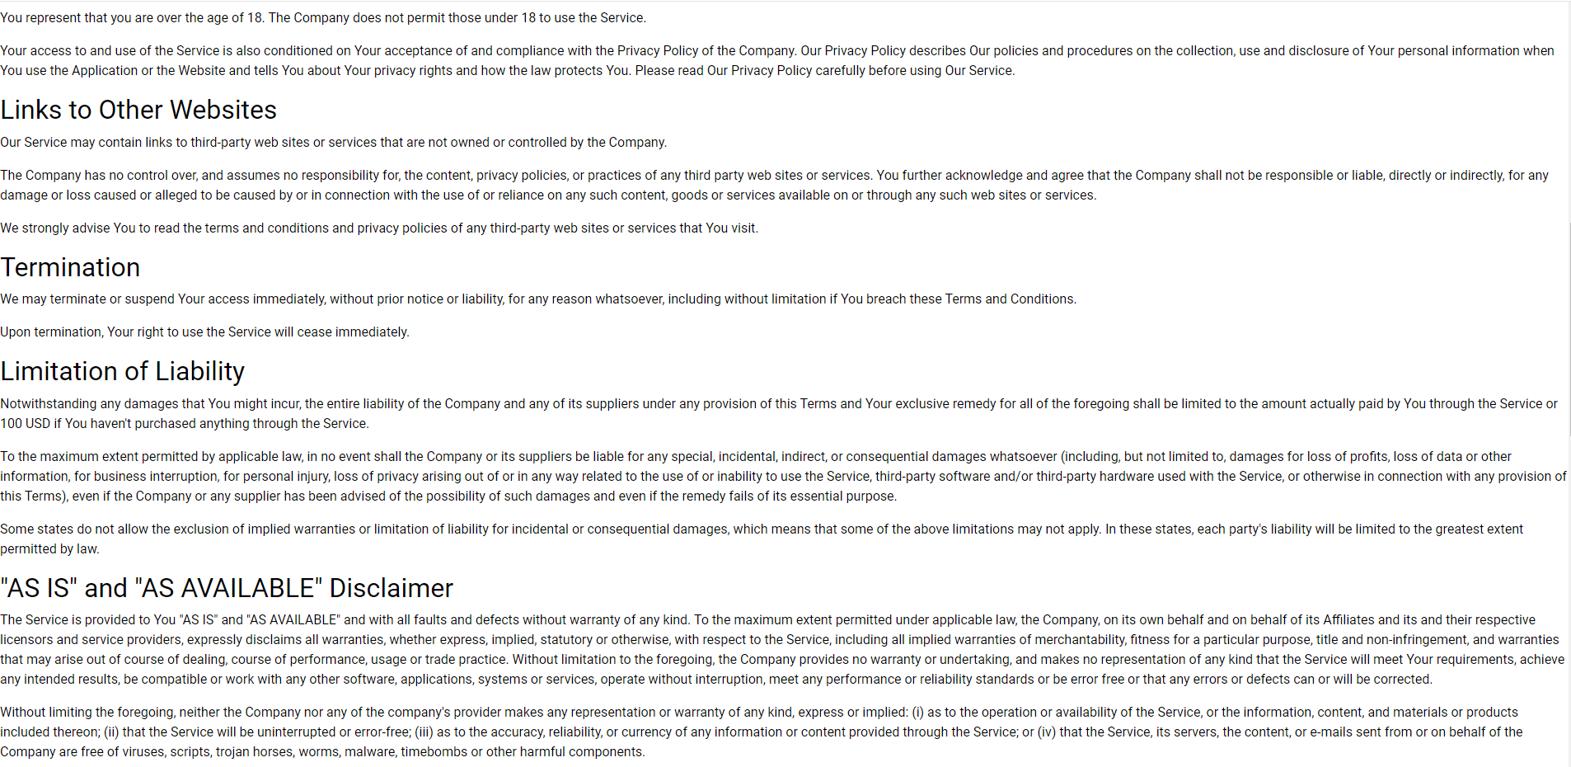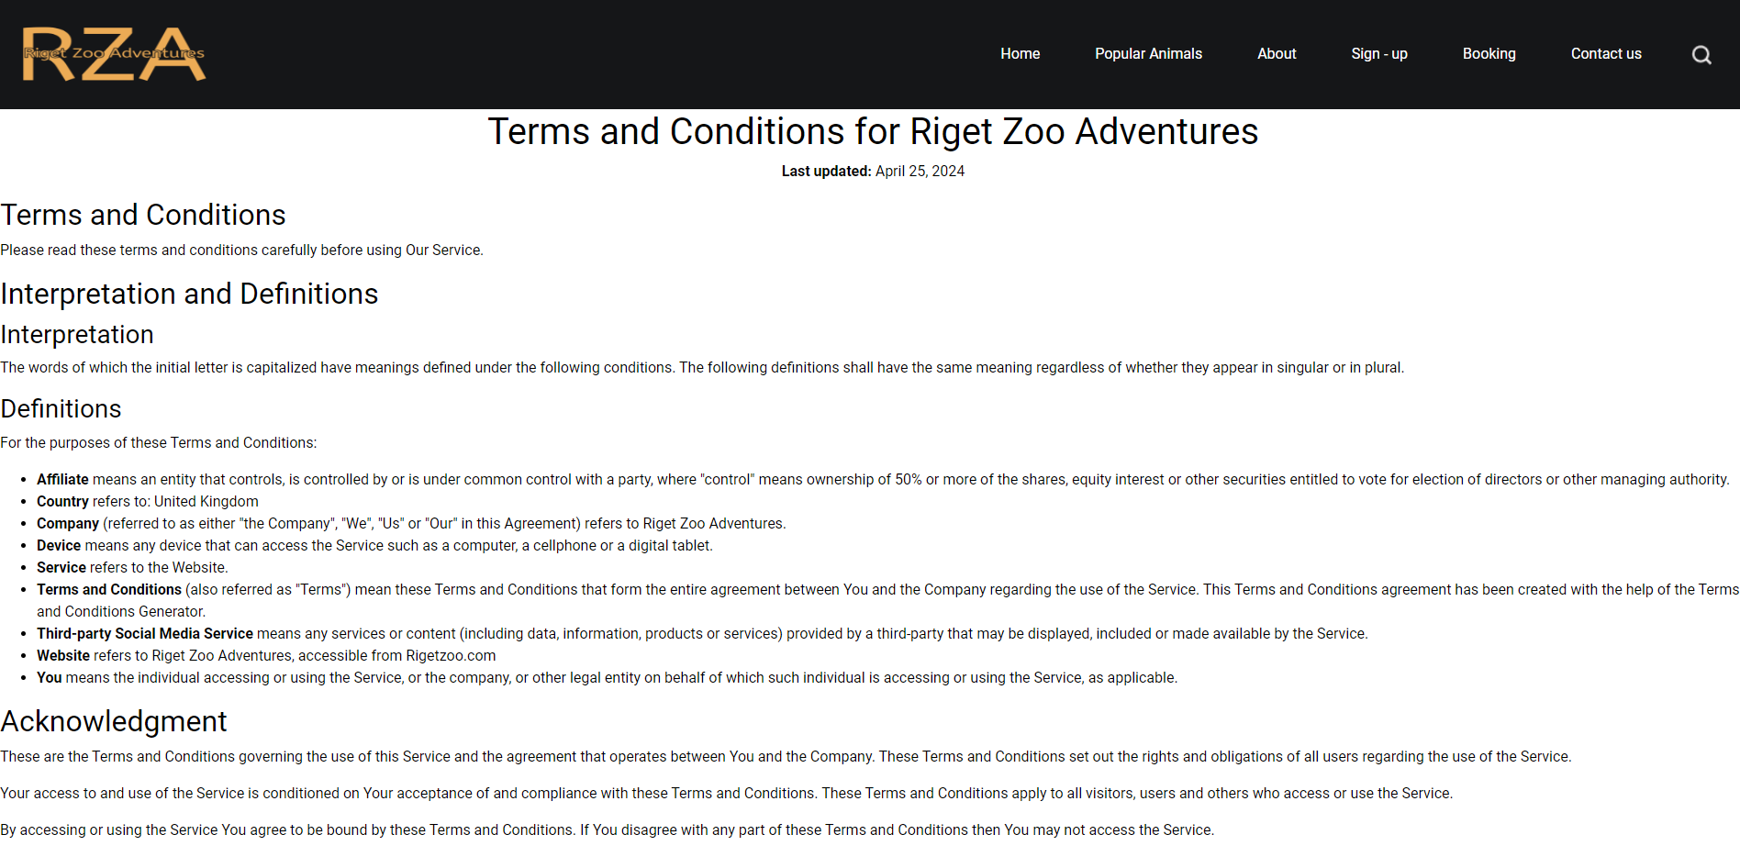

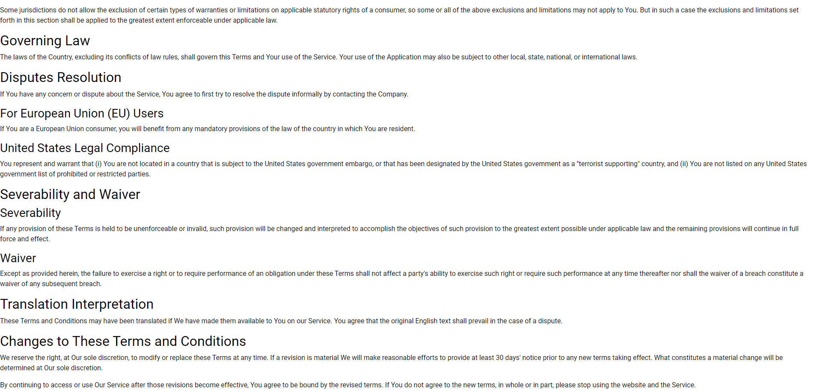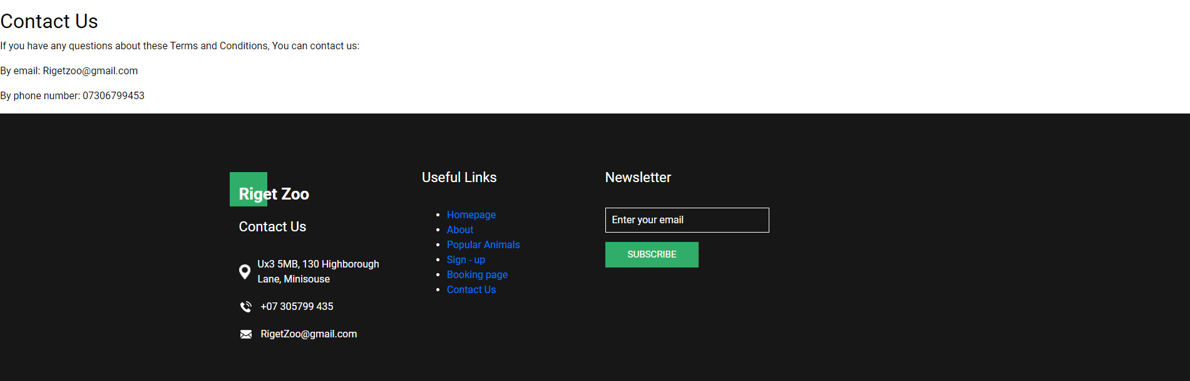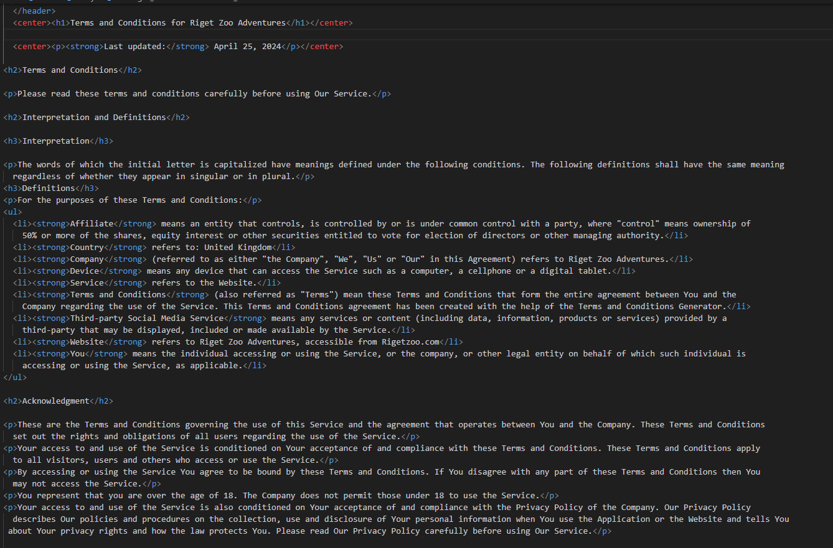 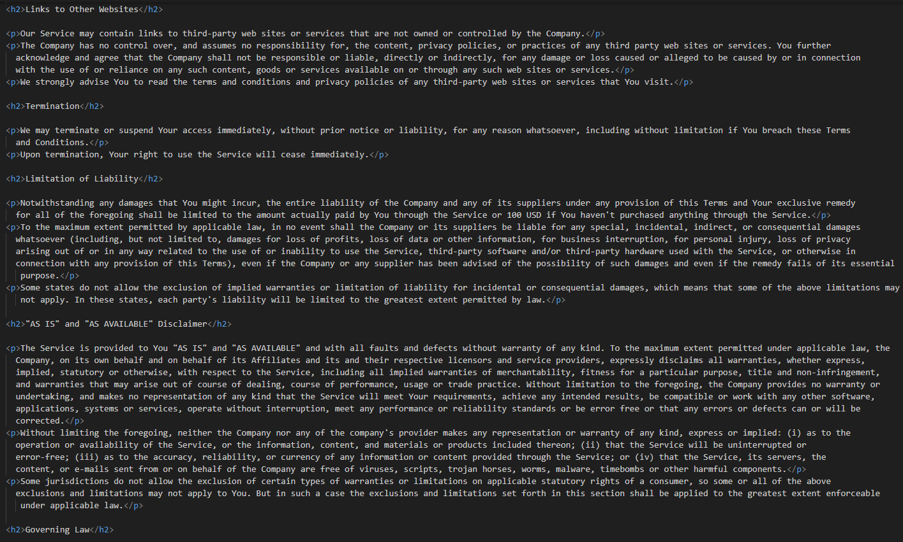

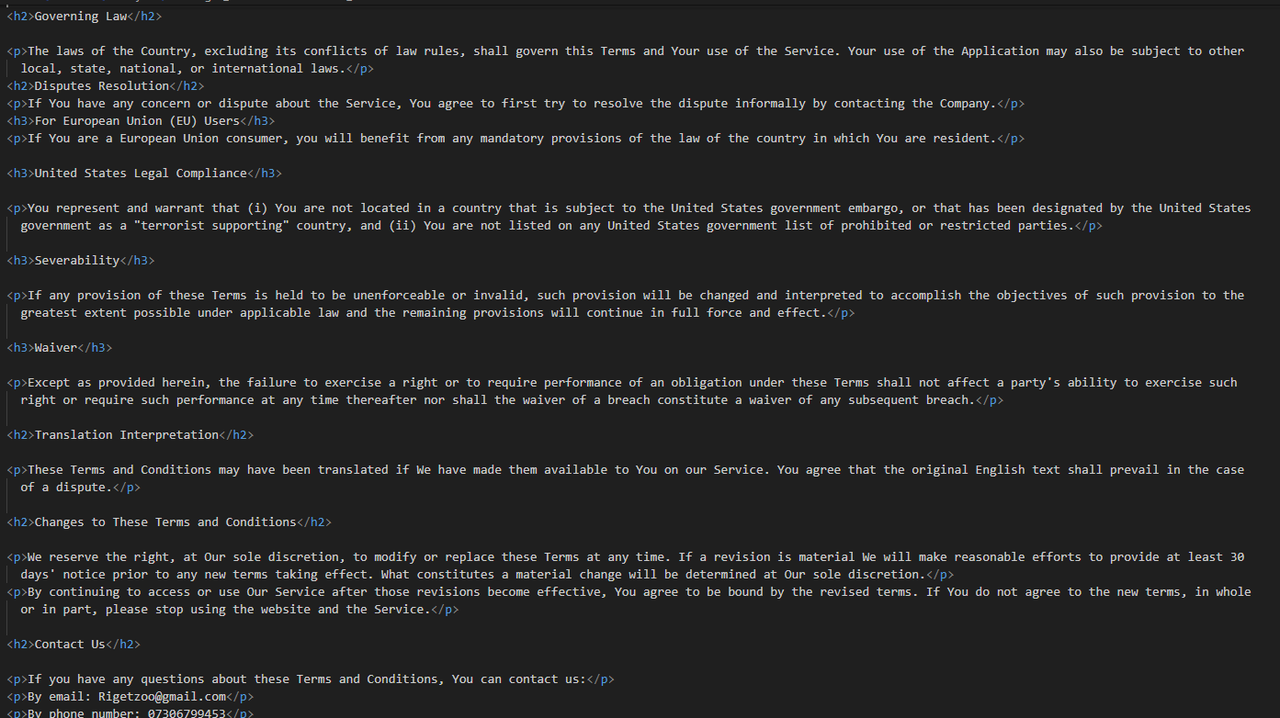

Background image

I set the background image of this page as an abstract image of some zoo animals all huddled together in order to try and invoke some sort of feeling of longing to see the cute animals in person. It may also make people more interested as cartoons may bring out the childish nature in some and make them think back to their younger year.

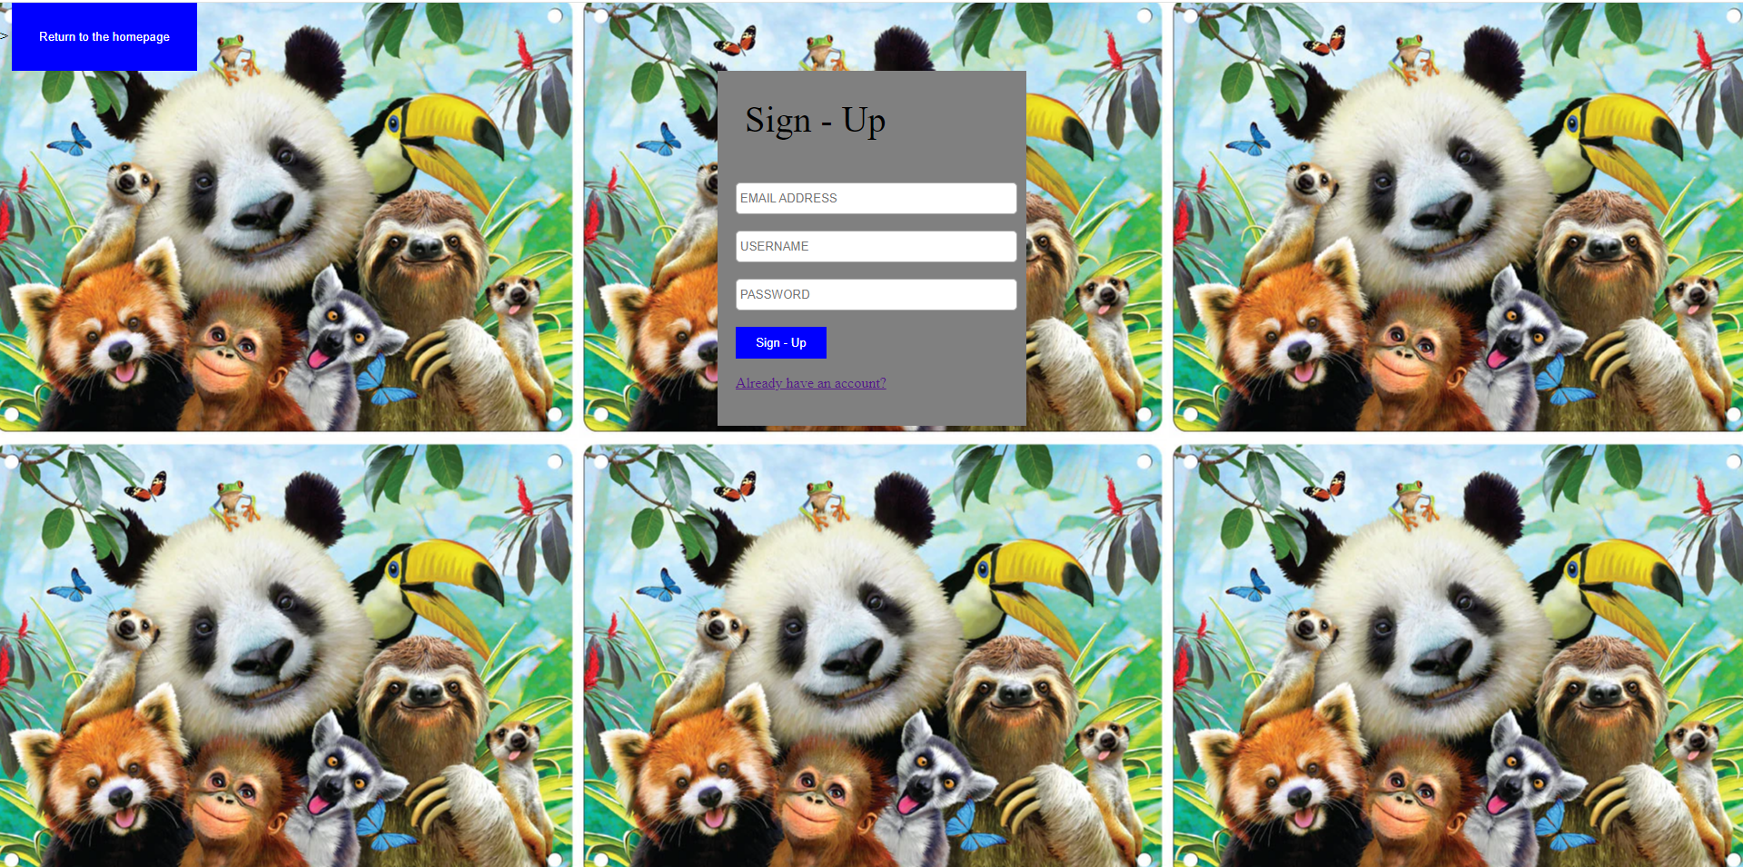

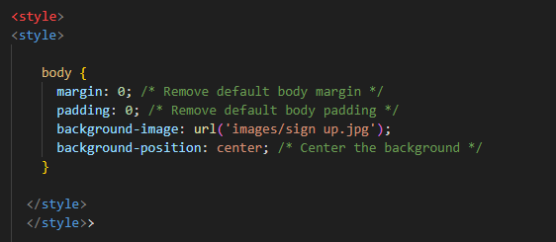

Login page

This like the login page has no footer or header but has the return to homepage button at the top left of the page. It has the same fields as the login page as the data that should have been stored should be replicated. However I didn’t have enough time to link the php code to this page and therefore wasn’t able to store the users data onto the database tables that I created. As a result of this I was unable to make it so that you could only login with certain credentials. this means that if you enter any data that fits the data structures then you will be able to gain access to the user dashboard. This also means that the data on the user dashboard won’t be personalized however this won’t be represented as you are unable to actually make bookings so the data on the dashboard will always show as empty.

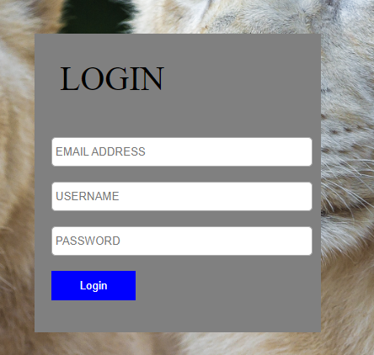

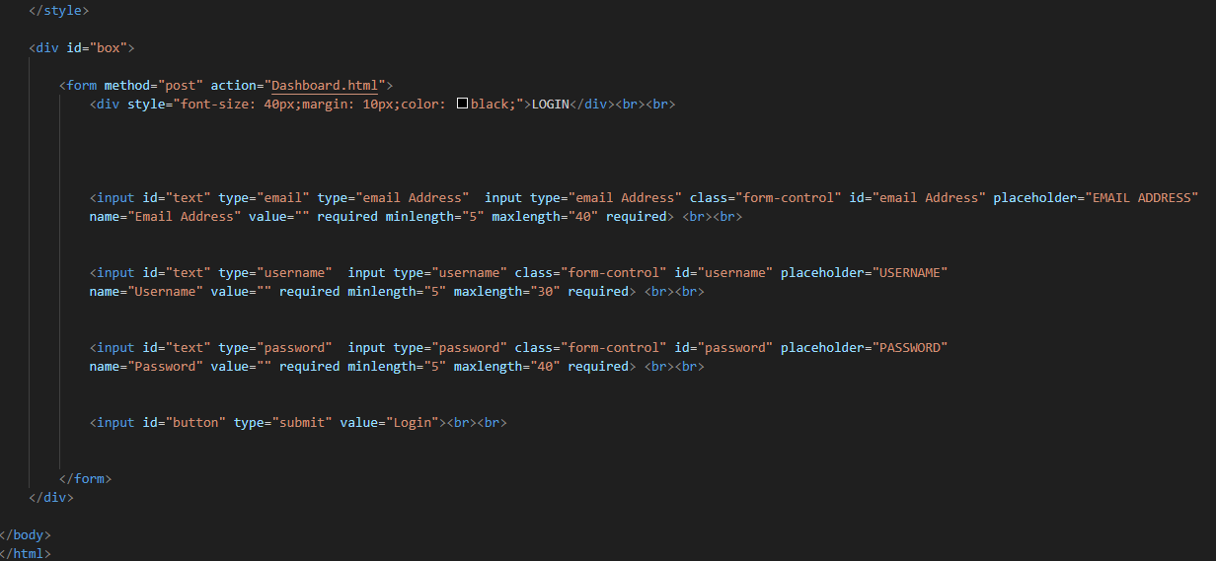

Login V2

I went back to the login page and wanted to change the CSS. I also added the TOS link to this page as well just to give the user another chance to view it if they missed it the first time.

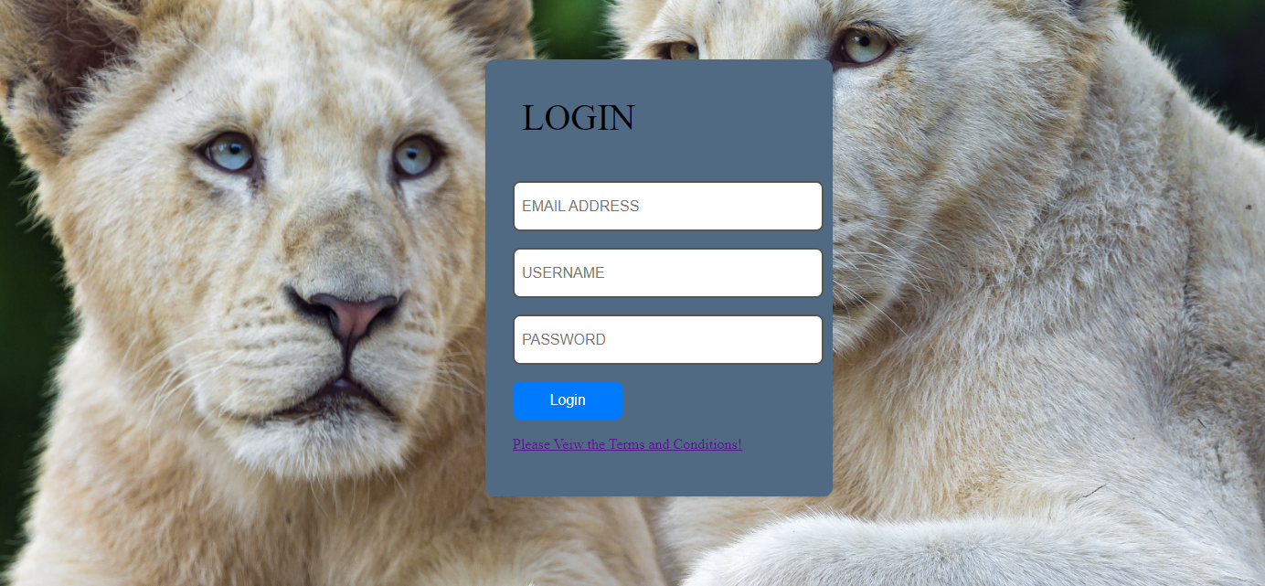

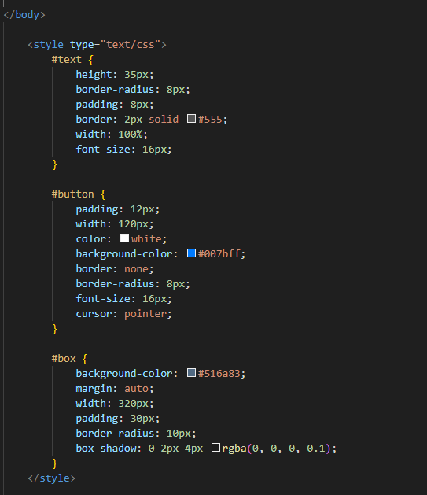

Background

for the background I used an image of twin lions. I felt that this was just a nice image that was of high quality and therefore put it here as I thought it fit the purview of what I was trying to represent.

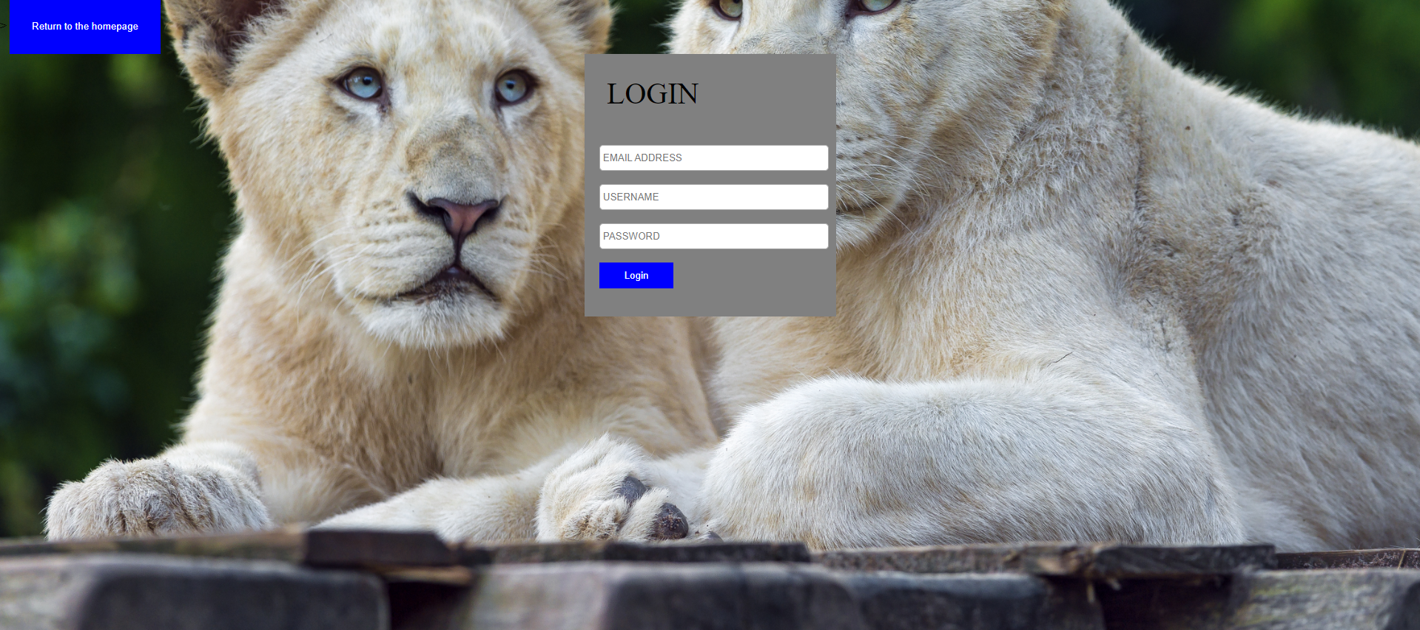

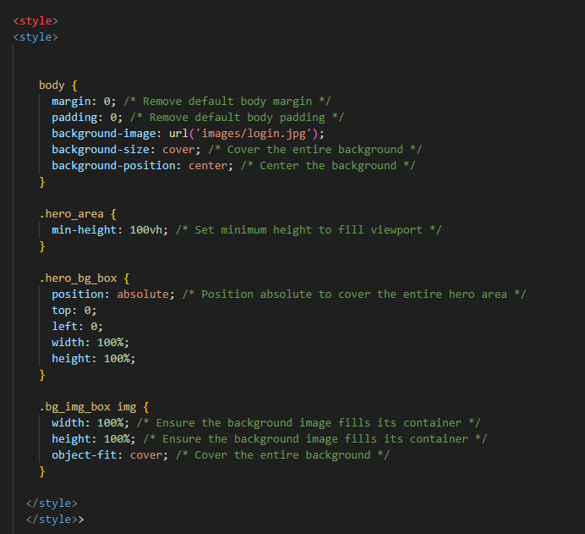

Dashboard

Once you login into your account you are faced with the user dashboard. This also has the same header and footer that the index page has. But the content of the page consists of a box that is divided into 3 rows the first row if the current bookings has 3 different data points. The first is Date of the booking. The second is the time of the booking and the third is the status of the booking so this would either be upcoming, current, expired. Beneath this there is the second row that would display the past bookings. This would have the same data points beneath it. Under this there is the last row that presents the user with their loyalty points. This will always be zero as I was unable to implement a working reward scheme that would have a counter that increases with each time that you do something that should affect it.

beneath this there is a paragraph detailing how you gain reward points. Finally at the bottom of the page there is a header called rewards and this is where 4 different rewards are shown to be available in exchange for loyalty points

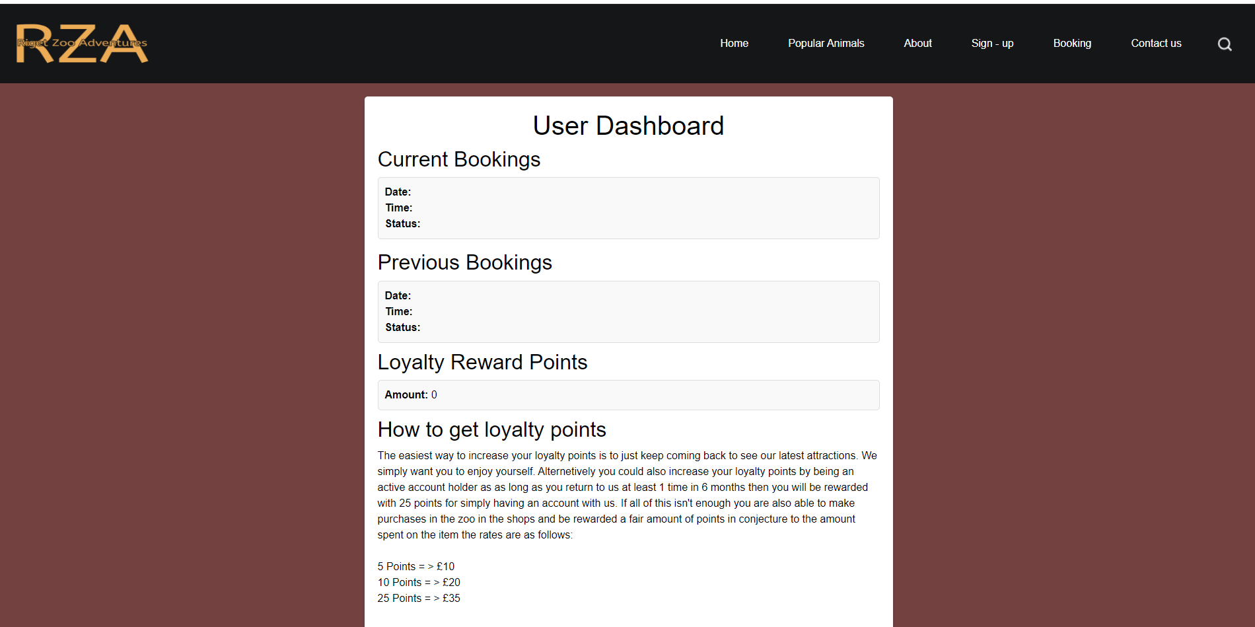

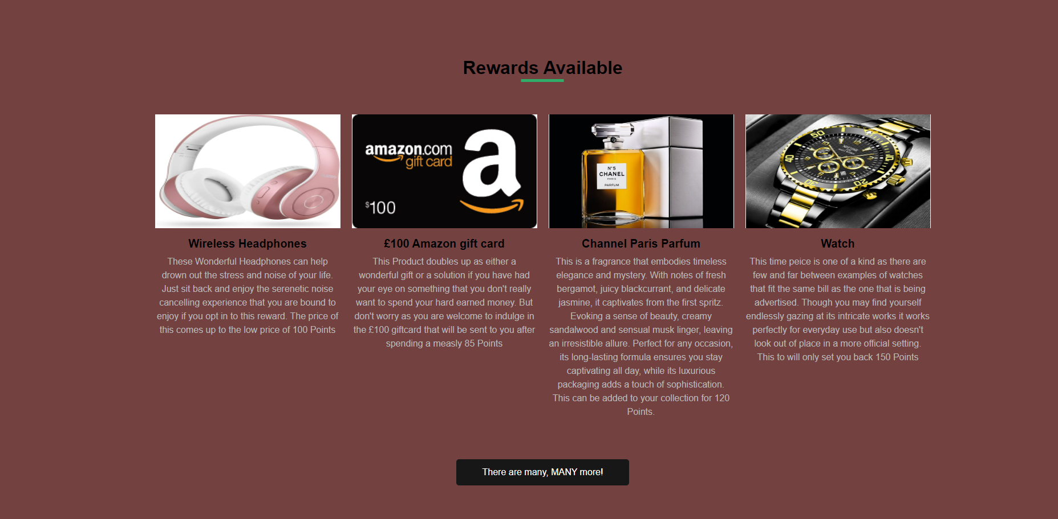

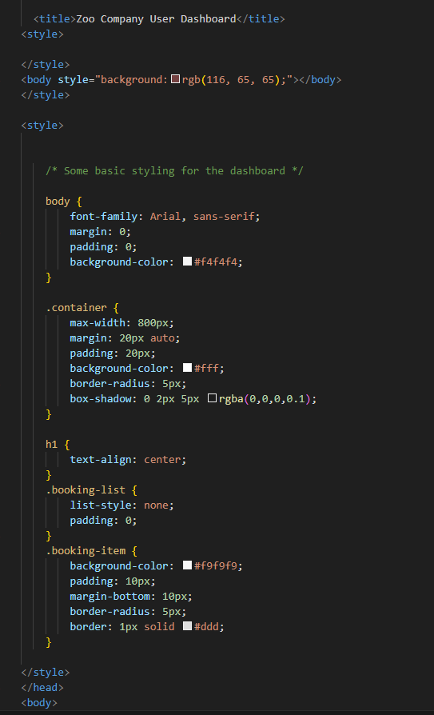

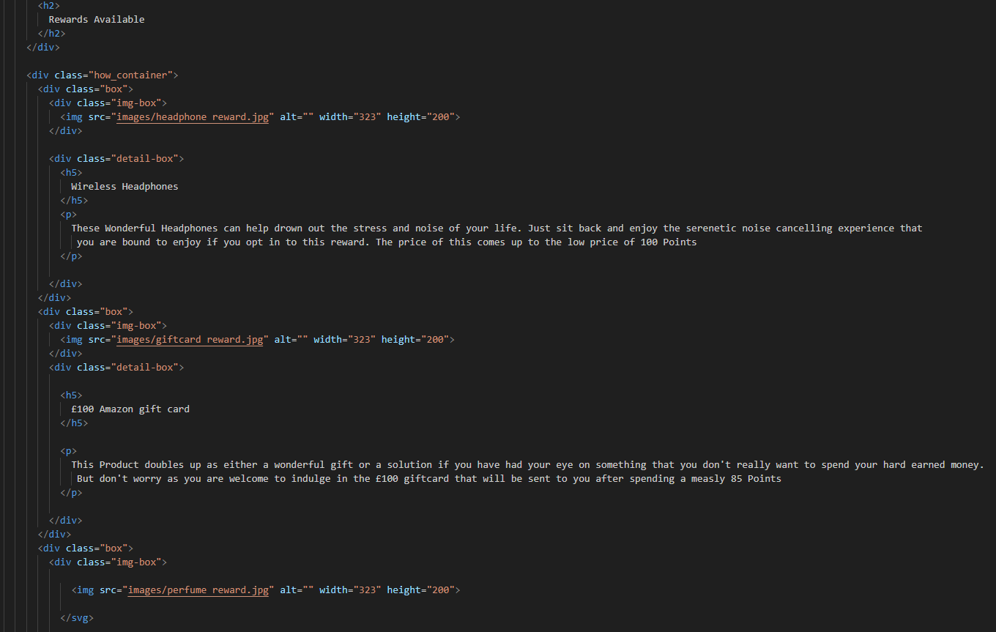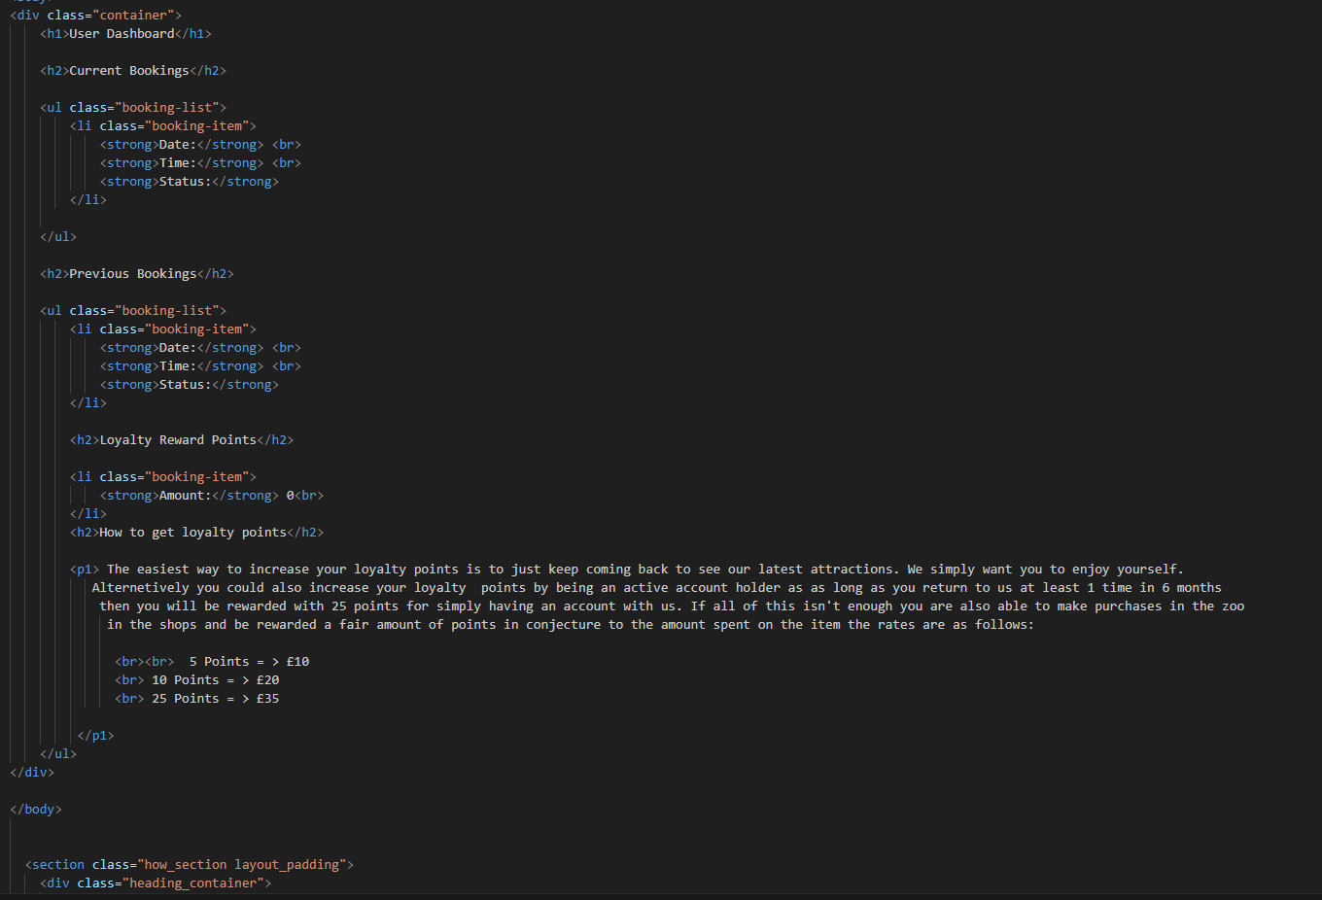

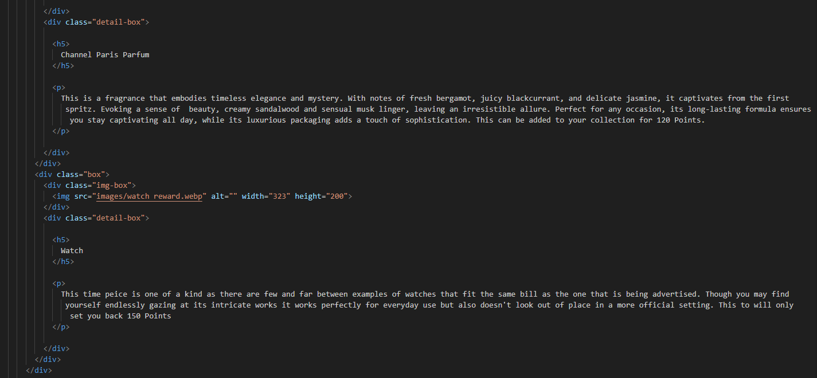

Contact us

The contact us page does have the header however it doesn't have the footer. The content of the page is a box with 5 rows. The first row is asking for the first name of the user, the next row is asking for the user's last name. Both fields are requiring a string data type to be entered. The next row is asking for the email address of the user. This must be in the format of an email otherwise it won’t be accepted. The next row is asking the user to input the country that they reside in. This field presents the user with a dropdown that hold quite a few countries and hopefully the user is from one of the countries that are there as understandably I was unable to add all of them. The final field that needs to be filled is the subject of why they are issuing this message. Under this there is a submit button. When clicking this if all the fields are filled correctly then it will take the user to a page that displays to the user that their message has been sent and will be responded to as quickly as possible.

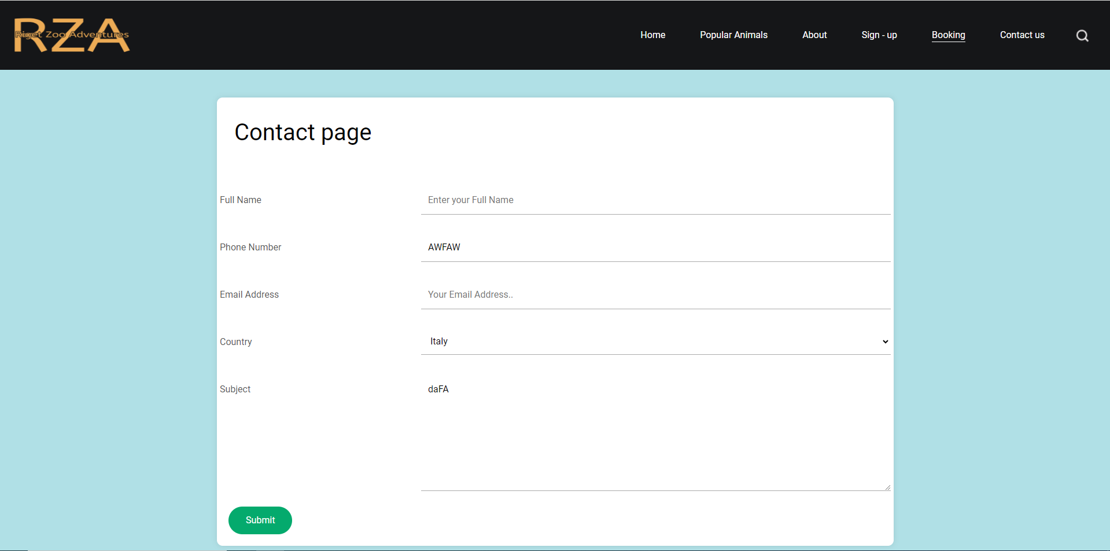

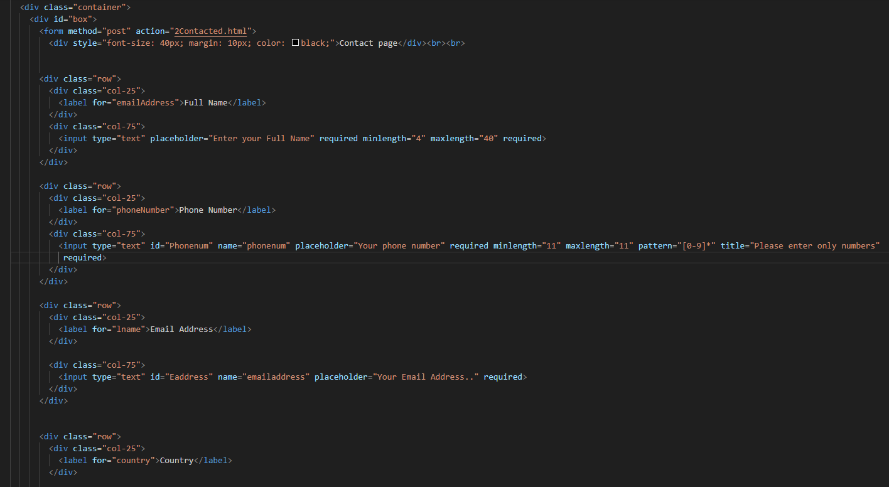

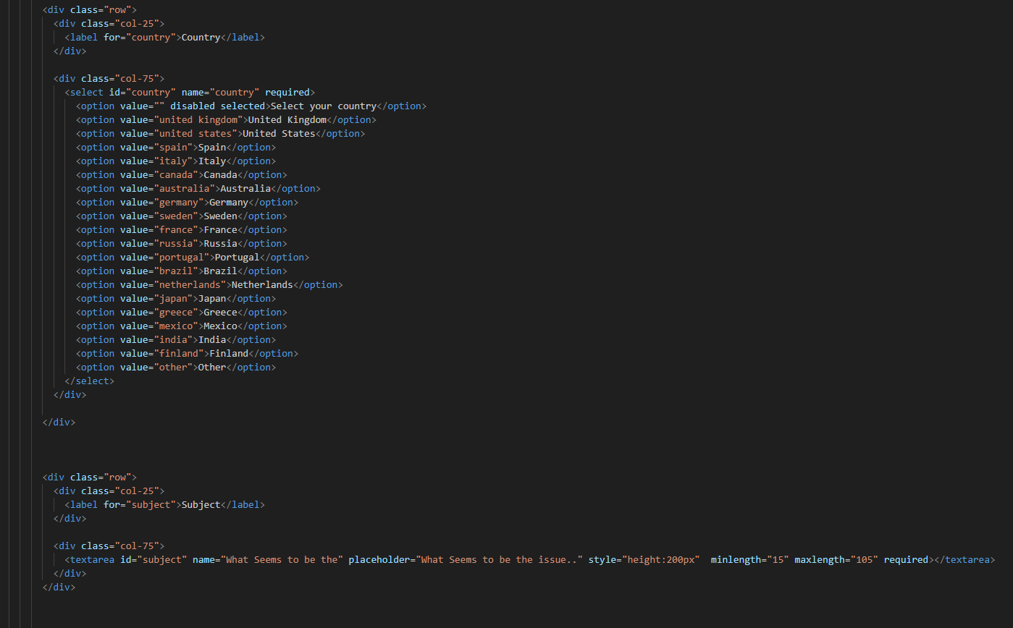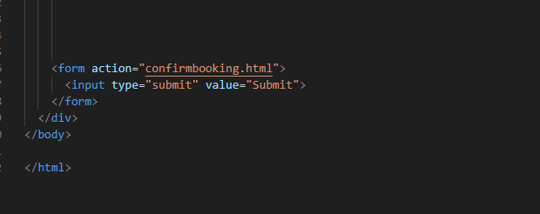

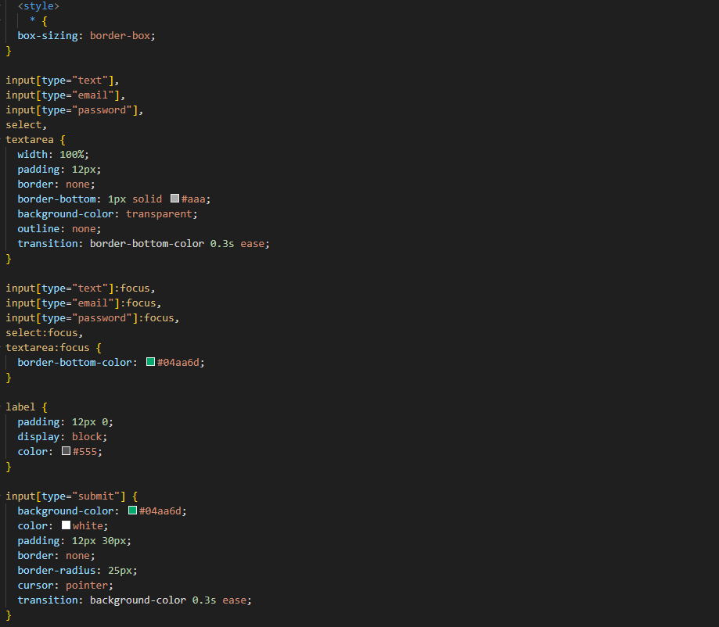

Booking page

to begin with it has the header however it doesn’t have the footer. There is a box in the middle of the page it has 8 rows and each one is a field that is required to be filled out in order to proceed. the first row is asking the user to input his full name. the next is asking for the user to input there phone number. I managed to implement code that checks if the user has entered 11 numbers as that’s how long a phone number should be if this requirement isn’t met then then you cant proceed. next is a drop down that is asking the user to enter which service they would like there are two options those being the hotel or zoo. next is 2 fields asking the user to highlight when there start data is and their end date of their booking will be. The date on the calendar is instantly on the current date making it easy on the user to select what they want. next is the users card details. This is requested in 3 different fields labelled card number, expiry date and ccv number. Finally if all the fields are filled correctly you can press the submit button and then be redirected to a page that tells you that your booking is confirmed.

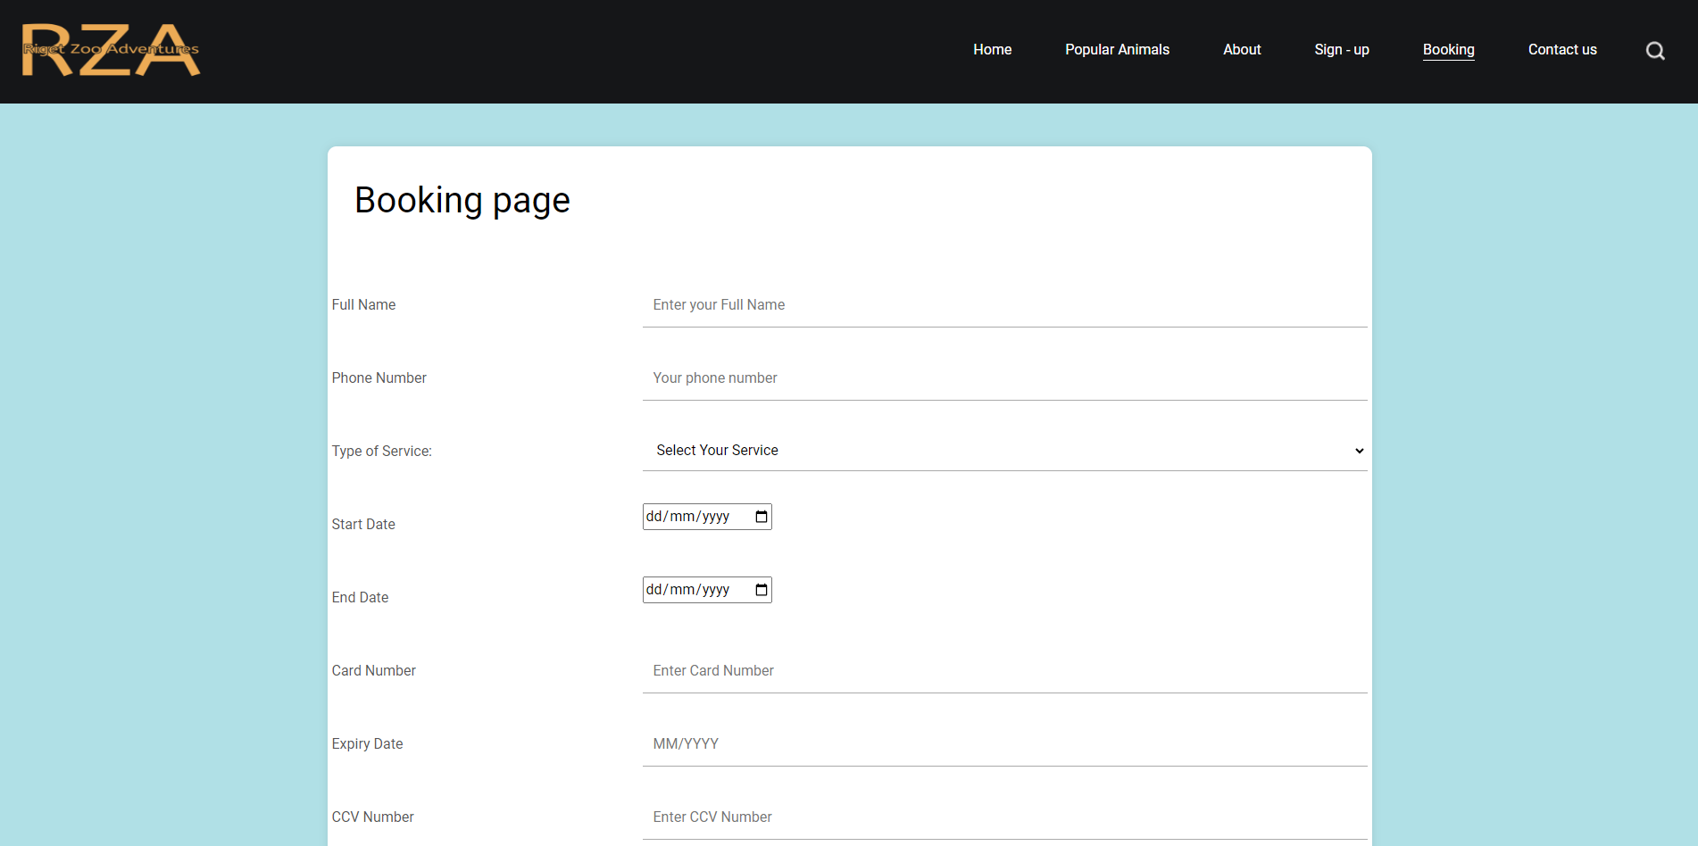

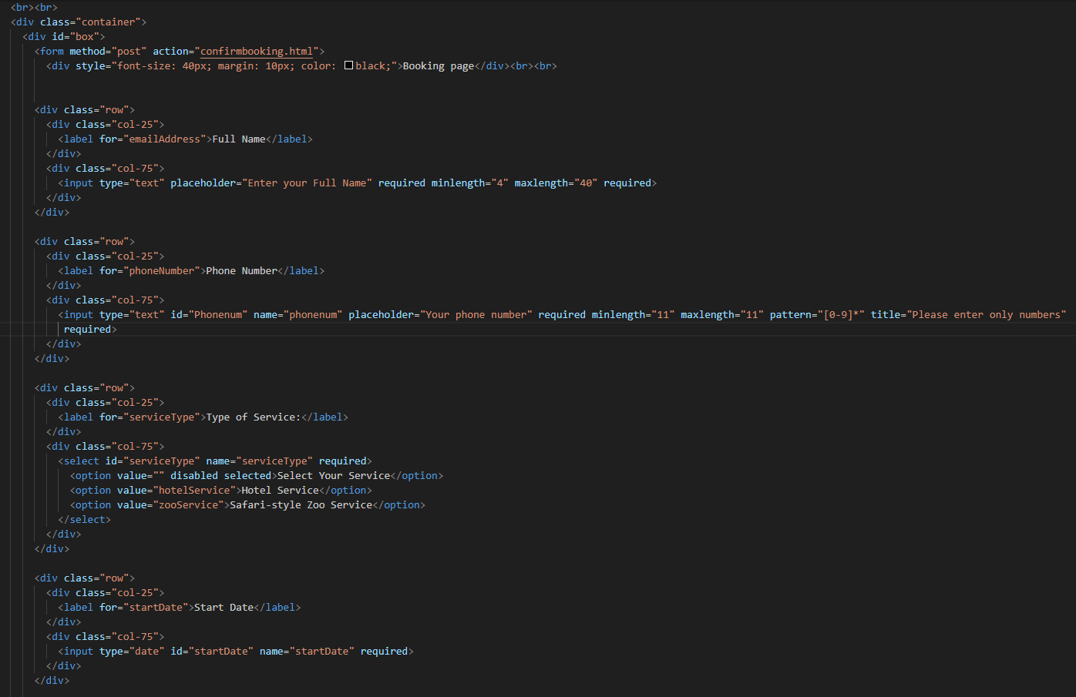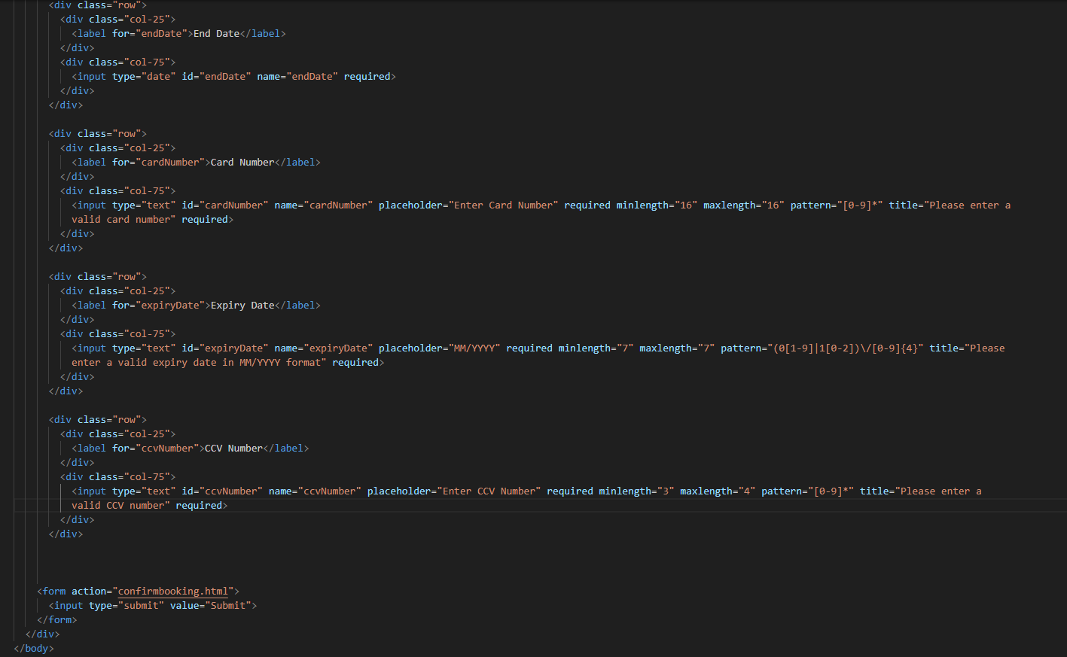

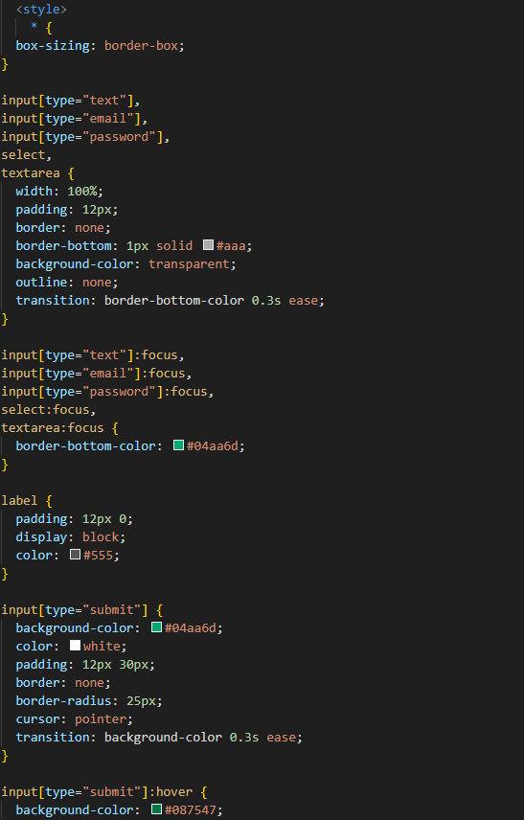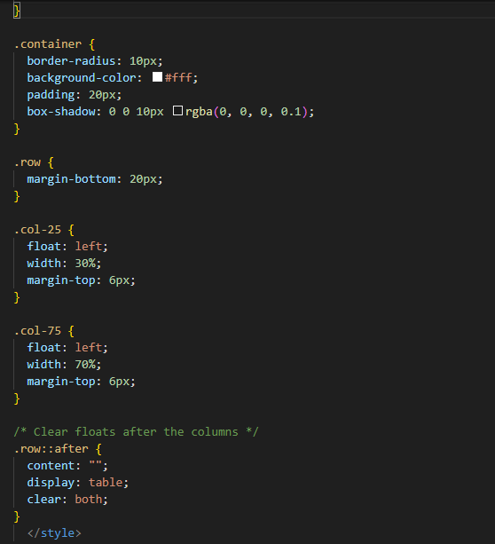

Template Used

<https://www.free-css.com/free-css-templates/page290/cryptop>

I used this template as I felt as though it would give me a great start on what I am working on and provide me with some pre written Java Script and CSS styling. Using this template saved me a lot of time as I didn’t have to do all of this which would have been very time consuming. I did however make it a priority to change as much of the coder as I could on the pages that it was already written on. However this template it particular that I chose did not have many pages and therefore it gave me the freedom of writing my own code for the majority of the website.

Terms Of Services

<https://www.termsofusegenerator.net/>

For the terms and services I used an online tool to generate the terms of services. I did this as writing all of it up would be a time consuming and laborious task.